

**CSEAAA (Section X)**

**[Summer 2022]**

**Lab Assignment Submission Report**

**Assignment Title: …………**

**Submitted by:**

**Your Name**

**Your Student ID**

**1. Screenshots**

Provide the screenshot of your Command execution for each problem/query.

**For CSE488, provide screenshots of different stages of your program execution.**

A sample is provided below.

**Problem 0:**

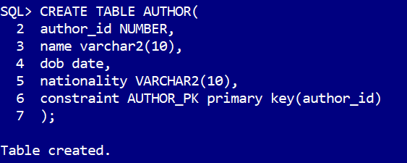

**Problem 1:**

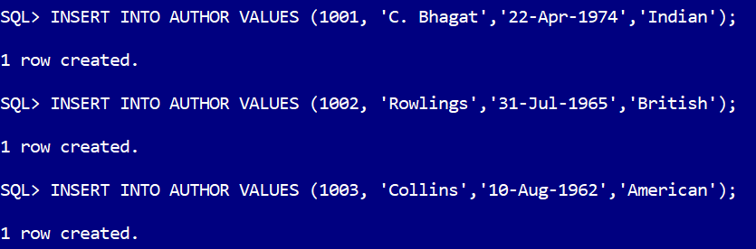

**Problem 2:**

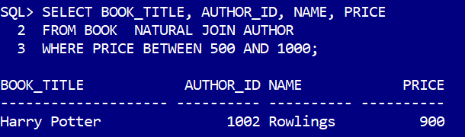

**2. Learning Outcomes**

Explain what you have learned through this assignment in your own words. **Do not copy-paste.**